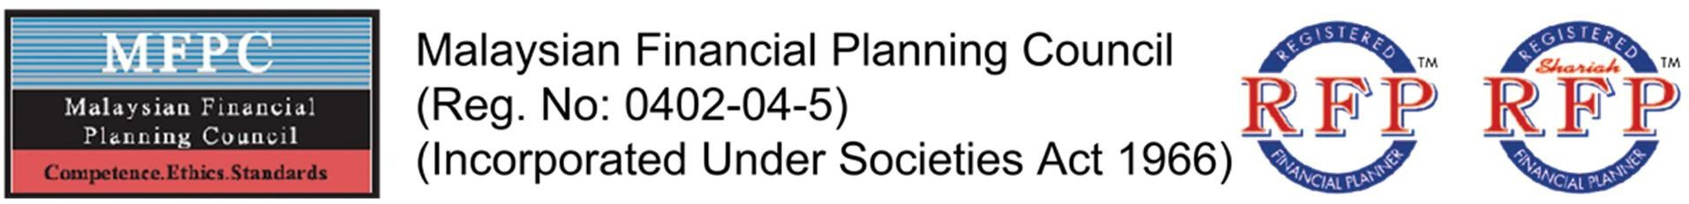

MEMO

Dear Fellow Members,

Waiver of Yearly Membership Fee for Fellow Member (F.MFPC)

Greetings from MFPC!

We wish to take this opportunity to express our sincere appreciation for your continuous support shown towards the MFPC since its inception in 2004.

We are extremely pleased to inform that the National Council, at the recommendation of the Membership Committee, has approved special waiver on Yearly Membership Fee for all Fellow Members effective 1 January 2023. You may verify your membership status at https://1st.mfpc.org.my/eid.

Fellow Members (F.MFPC)
This class of membership of the MFPC is conferred on RFPs or Shariah RFPs who are Ordinary Members and who, in the opinion of the National Council, have made outstanding contributions to the progress and development of Financial Planning in Malaysia. Membership may be conferred anytime deemed appropriate by the National Council and is by invitation only. Fellow Members shall enjoy all the rights of an Ordinary Member.

This class of membership shall be conferred with voting rights in accordance with Clause 922 hereof.

We look forward to working closely with you; and together we’ll continue to promote financial planning education to Malaysians and beyond.

Should you need further assistance, please contact the MFPC Secretariat at 03-6203 5899 or email to mfpc@mfpc.org.my.

Thank you.

Yours sincerely
Malaysian Financial Planning Council
Chung Kar Yin
Executive Director
Dated: 1st January 2023

SUITE 22.7, LEVEL 22, MENARA ONE MONT KIARA, NO. 1, JALAN KIARA, 50480 MONT KIARA, KUALA LUMPUR
TEL: 03-6203 5899, EMAIL: mfpc@mfpc.org.my WEBSITE: www.mfpc.org.my

